Comp 3000 Report
Introduction
Background
Why did I choose this project?
Bus Schedules are often integral to allowing for transit between urban and rural areas and are often either displayed through a physical schedule on a bus stop or digitally within an application. However these systems are extremely flawed with the physical schedule being more of a guideline then an actual schedule as buses are often prone to delays, especially in rural routes, and applications are either outdated or are unable to reflect delays. By chosen to create this application for bus scheduling it will allow users to receive more sophisticated and correct bus schedules as well as making it easier for admins to change these schedules.
Initial Research introduction
During my initial Research for this project I took a look a three scheduling admin applications, which are OmniTimes, the TPS Suite and the Trapeze Planning & Scheduling Solution for Ferry as well as regular use of the Plymouth city bus app. Within this section of the report you shall see an overview of features that users can find on these applications as well as the limitations that come with it.
Overview
The first application I would like to give an overview to is Omnitimes, as made by Omnibus solutions. OmniTimes is a versatile application made to produce schedules for buses, trains, tram
Services and ferry services with the main focus of Omnitimes being it’s capability to allow for flexible changes to Schedules. Such features include a Full override facility that allows for an admin to change anything from the time where a stop is scheduled to the name of the stop which would be useful when dealing with a late bus or a sudden shutdown of a stop within the route. It also allows for the admin to look at schedules from a single trip basis or a 24 hour basis which could allow for better organisation during the planning process of routes.

The second application I would like to give an overview on is the TPS Suite, made by Siemens AG. The TPS suite is a train timetabling application which allows for the planning of various train routes with a high degree of focus being placed on the long term timetable planning and real time train scheduling features that the service provides. The feature that interested me most was the TPS.live feature which allows for the train schedule to be changed or tweaked based on delays which is on of the main features of my project. Another feature I would like to highlight is TPS.trackworks feature which allows for the Admin to be aware of construction or maintenance on the routes which would allow for quicker and easier scheduling changes.

The third application I would like to give an overview of is The Trapeze Planning & Scheduling Solutions for Ferry, made by the trapeze group. The Trapeze Planning & Scheduling Solutions for Ferry ,or TTPSS in shorter terms, is a scheduling application with the main goal of being able to integrate the ferry's into the public transport ecosystem quickly and easily. One of the features I would like to focus on is the feature to allow for the start and end of a route to be plotted which would allow for quicker and easier route development.

The final application I would like to give an overview of is the Plymouth City bus mobile app which was researched to allow for me to get a look at what a normal commuter would be shown during an average day when they desire to get a bus. Overall the systems user interface was good with everything being able to to be seen clearly, colour coded bus routes for ease of use as well as the feature of seeing how long a bus would take to get to your specific location.
Limitations
Of course, as with all applications, there are limitation of which I shall list as these are the things that I am intending to fix with this project. The first Limitations that I will showcase are of that of the commuter side of the application which is the Plymouth City bus mobile app with the first limitation I would like to show would be the lack of accurate reporting on delays and cancellations within the system. Due to the fact that there seems to be no way to change a timetable when a bus is actively delayed, this can lead to the bus being anywhere from 10 to 30 minutes late without any notification from the app as well as the fact the timetable will stay static which means that you will be able to plan through the delays if the bus does arrive late. On terms of cancellations or major delays within the bus system, these are notified, however the only notification that is received is a Service Update which is often a bulletin that lists the times that the delays and changes that will be taking place over and are often confusing due to the fact that these announcements often include several stops at once and are copy and pasted tweets which means you have the additional visual clutter of hashtags next to the names of the route.

In term of the admin side of the application the first limitations that I would like to highlight are on Omnitimes. The main limitation to this application is the fact that, despite the fact that it can be easily changed and stops can be added and taken away, this is not often able to be done live either due to the fact the system has no in built reporting of these issues and also is more built for the concept of structuring timetables during the process of establishing and editing new routes and not for live updating. This means that delays can often go unreported and, if they are, then there needs to be a middleman involved where delays are shown in a different manner instead of being shown within a timetable which takes more time and is inefficient compared to the live service method.

The second set of limitations I would like to discuss is the limitations of the TPS suite. Whilst I believe to TPS system to be the most robust of the systems researched especially with the live service feature, there are several limits with the first one being the major disadvantages within one feature of the suite known as TPS.trackworks. This major disadvantage is that it only allows the user to access constructional measures that have been placed on the railway whereas it does not allow for delays to be accounted for in the cases of urgent issues such as trees falling on the track or more severe scenarios like the case where the South West peninsular in Dawlish collapsed and left that section of the route inoperable. Whilst rare and therefore easy to manage for trains if we apply this to our bus scheduling application it becomes a lot more of a issue especially since roadworks, crashes and fallen trees happen with way more frequency and as such the data would need to be updated more.

Finally the last set of Limitations I would like to discuss is with the TTPSS for ferry. Whilst having some impressive features a massive limitation of the system is that the route generated could be either wrong or inefficient which would lead to an increase in costs, time and future effort fixing the timetable where it instead could be made by hand and then made to be fit for purpose.
Objectives
The main objective of this project to create a service that not only allows for an easier and less stressful experience for commuters waiting for the bus as well as well as allowing for Admins and bus drivers to easily make these changes. As such my objectives are :
- Create an Application that allows for a commuter to look at real time updated timetables and see how late they are.
- Create an Application that allows an admin to create, edit and delete timetables in real time.
- Create an Application that allows a Bus driver to report an absence, a delay and allow then to view their shift start and end as well as any other personal details.
- To design an application that is easy and efficient to use.
Design
Requirements
After conceptualising the idea for B.A.S.S I proceeded to draw up a requirements diagram in order to break down the large amount of features that I had ideas for into only the features I felt would allow for a good user experience for the application. Below is the requirements diagram :
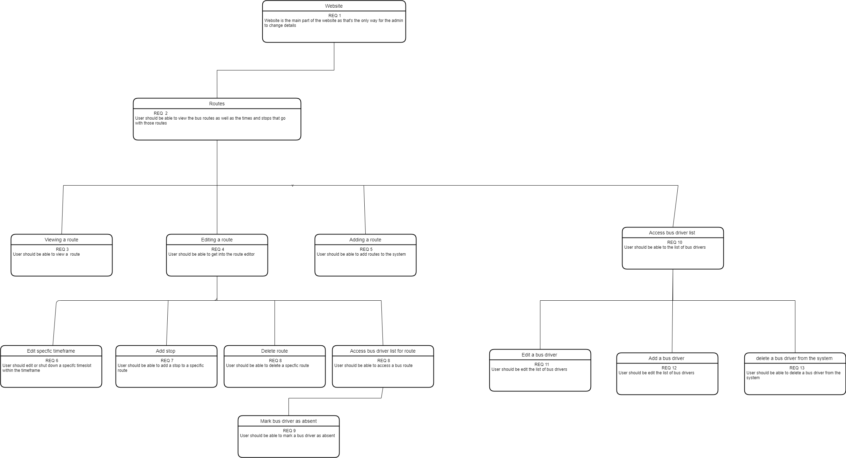
User Stories
After initial requirements of the system were found, user stories were created. User stories are explanation of a software feature from the perspective of the user, usually having a desire to do something followed by the steps needed in order to get it done which lead to the end result. Below is the user story diagram as well as a table which goes into some more detail about the user stories :

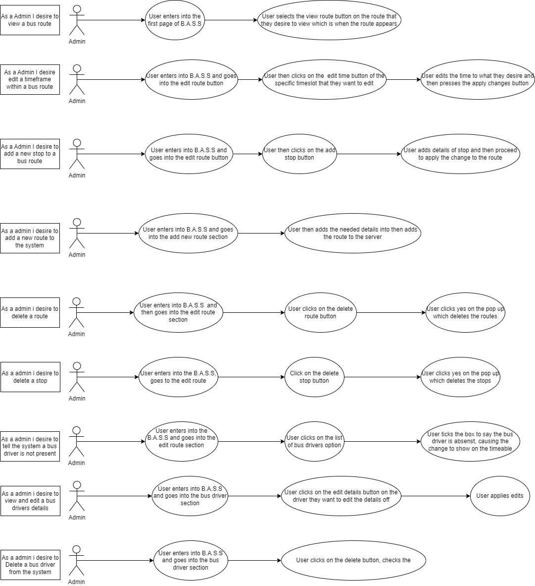
Title | As a | I want to be able to | So that I can | Given a user | when | Then
View bus route | Admin | View a bus routes schedule | Know what times the buses are supposed to arrive at | Clicks on the “View schedule” button on the route they desire | The user views the list of routes | Go to the route and show the timetable
Edit a timeslot on a route | Admin | Edit a timeslot | So that a bus delay is reflected into a timetable | Clicks on the edit time button and types in a correct time | The user edits the timeslot | The timeslot would be edited as well as apply the delay to the other timeslots for that trip
Add new stop | Admin | Add a new stop | So that a newly added stop appears on the timetable | Correctly inputs ID in the add stop area. | The user goes to add a stop | The stop would be applied and able to edit and use it.
Add new route | Admin | Add a new route to the system | Be able to view and edit a timetable in the future | Does not make an error | Within a creation of the timetable | The new route and timetable should be uploaded
Delete route | Admin | Delete a route from the system | Make sure no one is able to view said route | Presses Yes | The delete pop up appears | The Route should then delete itself
Delete stop | Admin | Delete a stop from the route | To make sure that stop is no longer on the timetable | Presses Yes | The delete pop up appears | The Stop should then delete itself
Mark bus driver absent | Admin | Mark a bus driver absent | To make sure the delay from this bus driver being absent is reflected on the timetable | Ticks the box | When on the list of bus drivers | The bus driver should be declared absent
Edit a bus driver | Admin | Edit the details of a bus driver | Make sure those details are correct | Inputs the correct details | After clicking the edit button | The Bus drivers details should have been edited
Delete a bus driver | Admin | Delete a bus driver from the system | Allow for a driver who has left employment to be removed from the system | Presses yes on the pop up | After clicking the delete button | The bus driver is deleted from the system

Wire Frames
After planning out the features of the web application I proceeded to design several wireframes to gain an idea of what the UI would look like before I started to code. This would also allow me to reflect on any changes that I would make to the UI in the future :
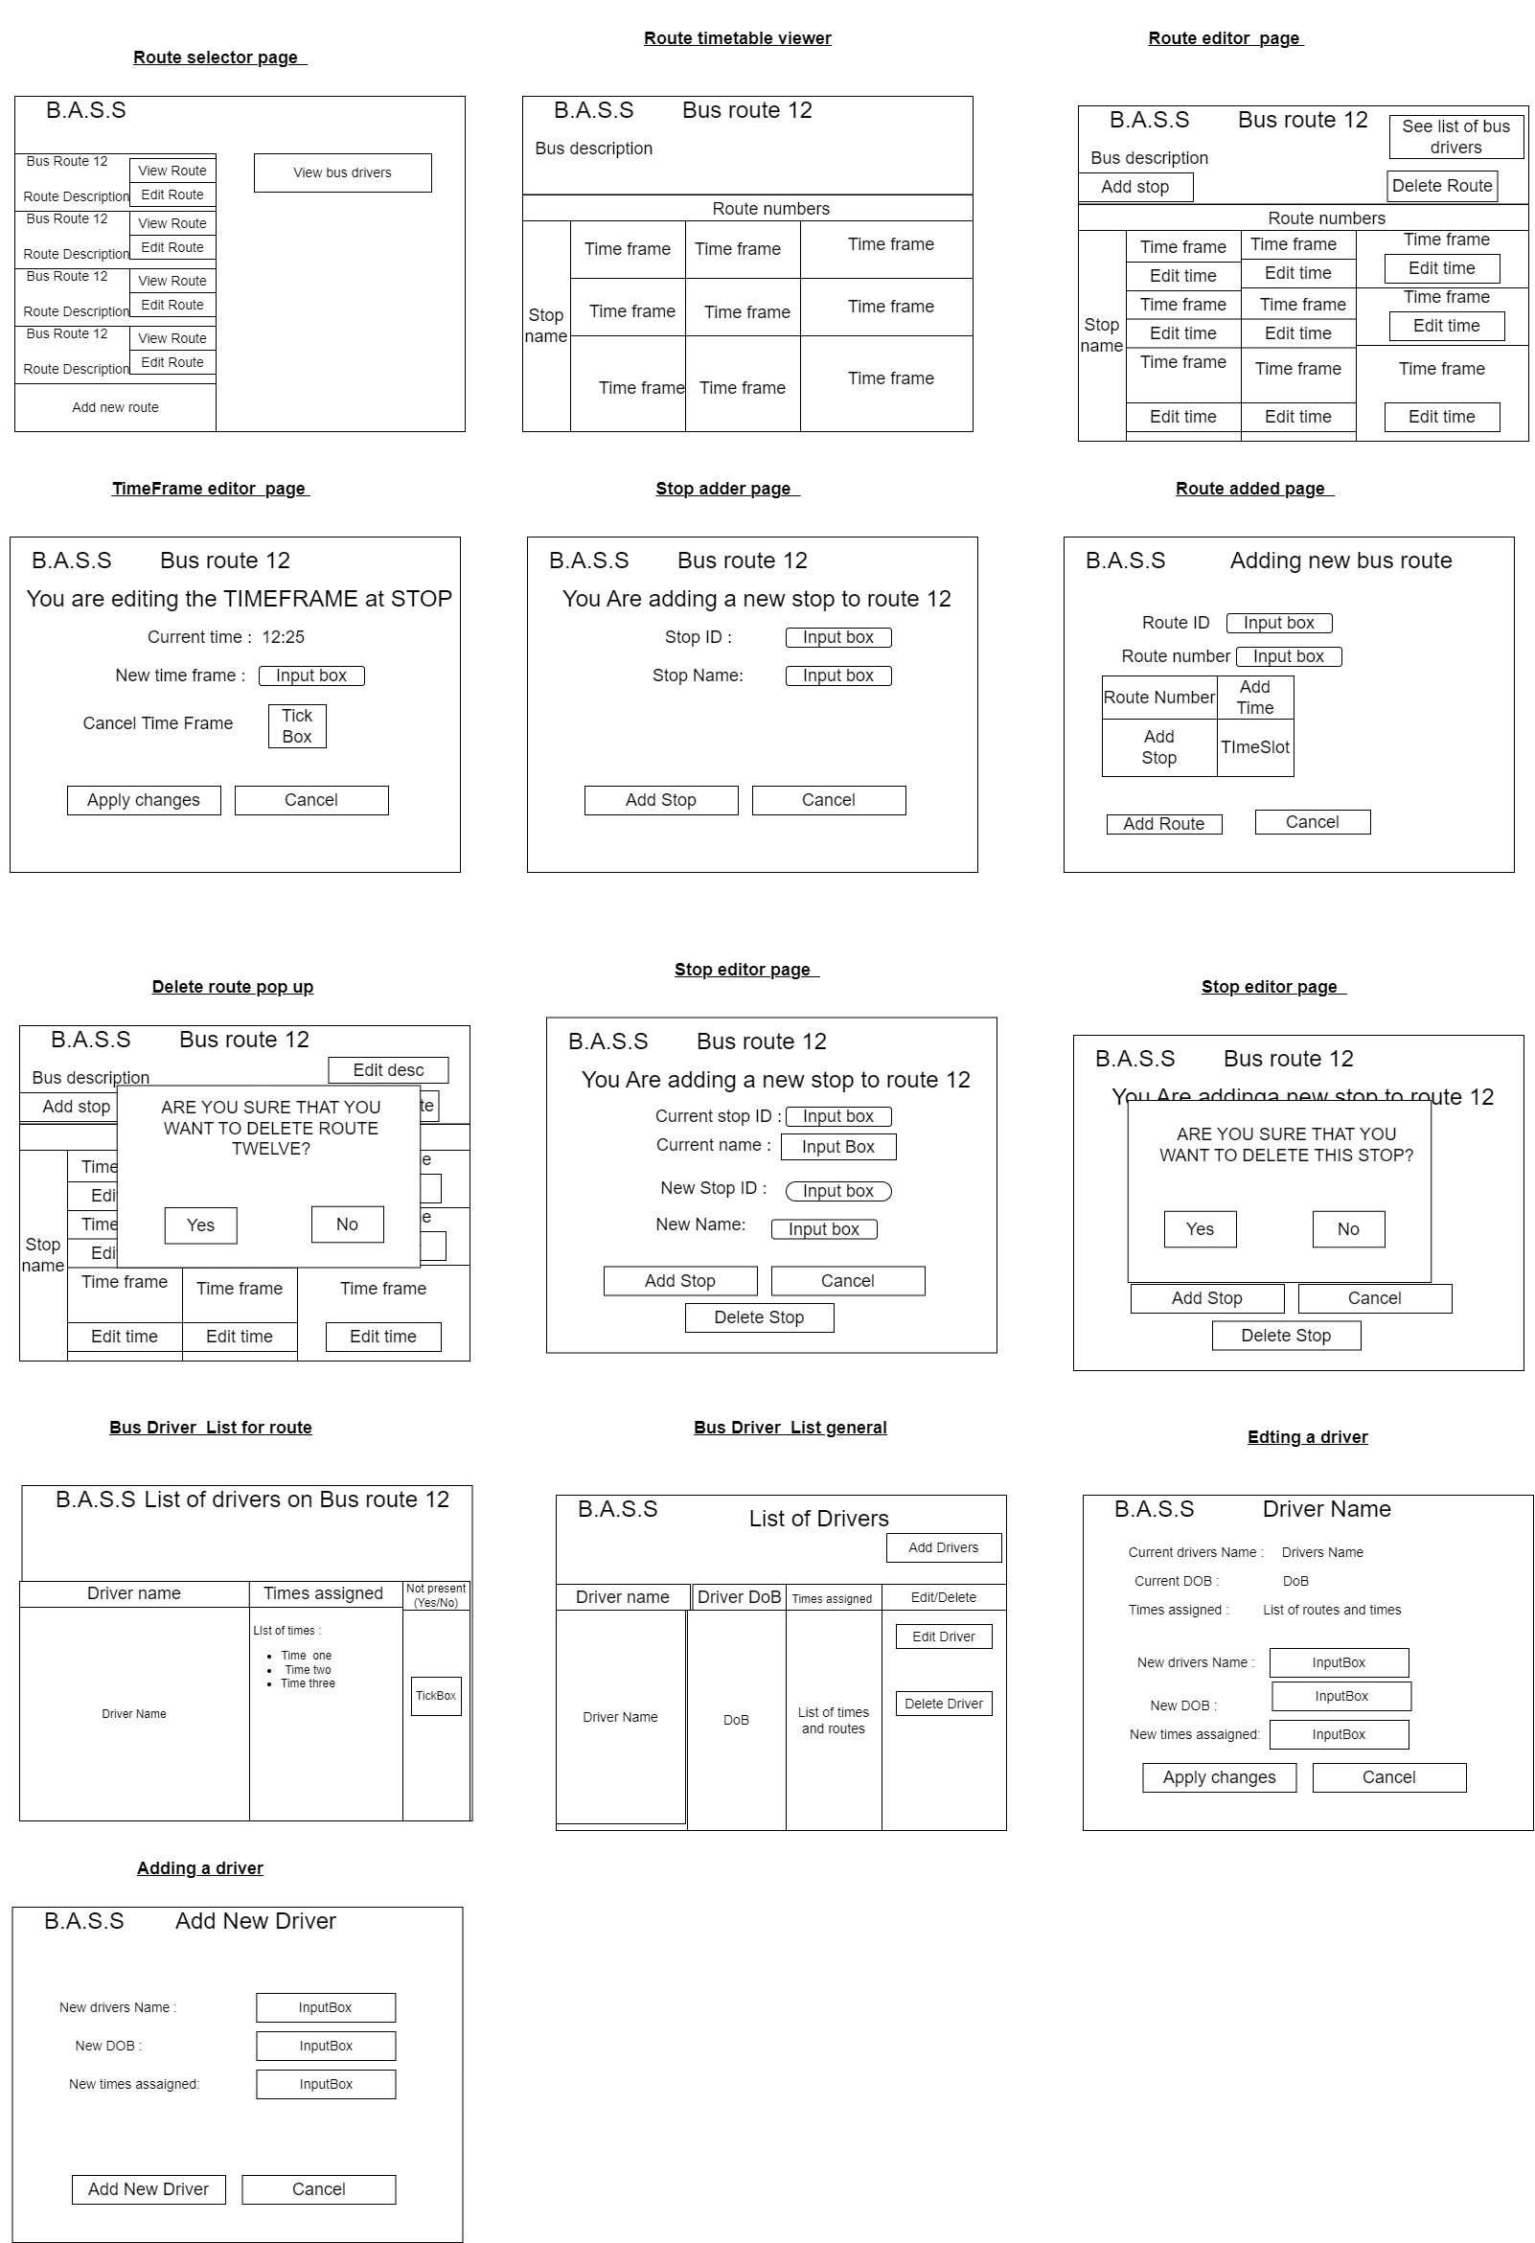

Normalisation diagram
UNF | 1NF | 2NF | 3NF
Route ID  RouteName  RouteNumber  Description  RouteDirection  BusDriverID  (Busdrivername  BusDriverDOB  BusDriverTimes  BusDriverRoutes  PresentStatus  )  (Stop ID  Stop Name  Stop Time  DelayedCheck  DelayMessage  )  UserName  Password | Route ID  RouteName  RouteNumber  Description  RouteDirection  Route ID  BusDriverID  Busdrivername  BusDriverDOB  BusDriverTimes  BusDriverRoutes  PresentStatus  Route ID  Stop ID  Stop Name  Stop Time  DelayedCheck  DelayMessage  UserName  Password | Route ID  RouteName  RouteNumber  Description  RouteDirection  Route ID  BusDriverID  BusDriverID  Busdrivername  BusDriverDOB  BusDriverTimes  BusDriverRoutes  PresentStatus  Route ID  Stop ID  Stop ID  Stop Name  Stop Time  DelayedCheck  DelayMessage  UserName  Password | Route  Route ID  RouteName  RouteNumber  Description  RouteDirection  Driver Allocation  Route ID  BusDriverID  Bus Driver details  BusDriverID  Busdrivername  BusDriverDOB  BusDriverTimes  BusDriverRoutes  PresentStatus  Stop Allocation  Route ID  Stop ID  Stop  Stop ID  Stop Name  Stop Time  DelayedCheck  DelayMessage  Account  UserName  Password
ERD diagram
When creating a database it is useful to make a ERD diagram. A ERD diagran A Entity Relationship Diagram shows the relationship between several components of a database I. One route will have many bus stops within it :
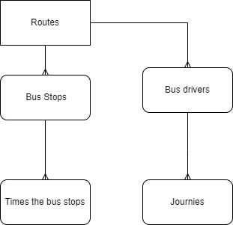

Method of approach
Agile
This project was made using a methodology known as Agile. The Agile Methodology is based on the concept of breaking the project into smaller subsections which are then planned out and acted upon in a series of actions that are known as sprints of which will be detailed within the scrum section of this report. Overall it allows for the coding tasks to be done in small, easy to plan chunks compared to other methodologies which make it so you have to deliver one large segment

One of the main advantages of this system is that it is a fluid one as it allows for the Developer to react to changes in the requirements if something does or does not work and as such means that these changes don’t slow down development since it compensates for the time that is available. Due to the size of this project being somewhat small and the fact that only one person is developing it compared to a group I believe that it was the best choice for this project.
Scrum
Scrum is part of the Agile project management framework where the project is broke down into a series of small, two week segments known as sprints. Sprints are usually small tasks that are set to be done within the two week timeslot with the main goal being to deliver upon your splits when the two week period is over which slowly builds up the project over the course of a long period of time. Besides from the advantages listed above with being able to be fluid with tasks, Scrum also allows for management to be much easier and more well planned due to the fact that the time frames and tasks are small compared to the more monumental tasks and time frames that other method manage to provide for.
Development
Research Stage
The first stage of my project was to focusing on research other scheduling products that were on the market as well as figuring out what features my product would have to to enhance the bus scheduling experience as well as figuring out what technicologies would be used to create my project and constructing a project brief going over any risk factors that my project may encounter. As explained within the background section of this report, I have look into three products which are OmniTimes, the TPS Suite and the Trapeze Planning & Scheduling Solution for Ferry as well as my experience using the Plymouth bus application to plan for what features to include and what UI details to give my UI. For the first three products I used a method known as MoSCoW which stands for must-have,” “should-have,” “could-have,” and “won't-have” which is a method where I would point out specific features I would desire and categorizing them as being something that I must have within my project, things that could be in my project and things that I desire to be in my project but simply may not have the time to include. Thank to this research it has shown me that that the main feature of my project which is the live rolling times, would be possible as well as giving me ideas for other features such as incident reporting.

During this time a project brief was also created which highlighted my plans for this course which included the vision for my project as well as the risk plan which highlighted several risks I could face such as moving house and organizational issues and my proposed sprints for my project. Thanks to the fact I used the Plymouth bus service app at least two time a day at the time I was planning I was able to monitor how late the busses usually were as well as being able to make sure that it was able to reflect the experience that the Plymouth bus service app is able to provide. After thinking about the technologies I would be using I eventually decided to use Microsoft SQL as well as using C-sharp and html to code the main area of my application.
Stage Two
Stage Two of my project consisted of planning out the look and uses of my project as well as planning out the general structure of the database. Firstly I set about drawing a requirements diagram which was where all of the requirements were displayed as well as how they link to one another and which ones would have to be complete in order for things to be planned correctly. User stories were soon made as to show how the user interacts with the system as well as the process the system goes through to get the desired result for the user. When planning my database I used diagrams such as a ERD diagram which allowed me to show what part of my database interacted with other parts of my database.
Stage three
Stage three was when the first section of my coding began with this being mainly to add the core features of my application together such as ensuring that all pages within the wire frames are at least present within the code base
Conclusions

